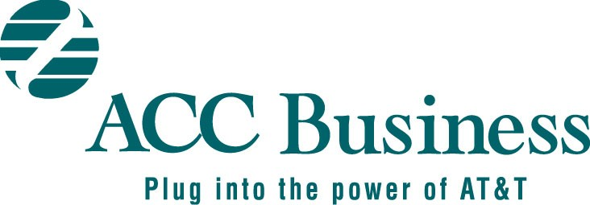

ACC SA 302

Letter of Authorization to Obtain Customer Service Records Only

Customer Name: | AT&T | Customer Account #:
Customer Full Address & Zip: | AT&T Full Address & Zip:  400 West Avenue  Rochester, NY 14611-0000 | Customer Contact:  Tel. #:  ACC Business Contact:  Tel. #:  Email ID:
Agent Name: |  | Agent ID:

- I appoint AT&T as my agent to request Customer Service Records (CSRs) with the Local Exchange Company(s) (LEC) for analyzing Local Service. AT&T may request CSRs for all telephone lines associated with the main Billed Telephone Number(s) (BTNs) listed below or in the attachment. If this authorization does not specify the specific BTNs, this appointment shall extend to all service accounts for which customer appears as the customer of record.

2. This Appointment is APPLICABLE TO THE FOLLOWING LOCATIONS | Blanket LOA  (For all locations in the United States) | YES NO
(CHOOSE ONE) | Location Specific LOA  (Specify applicable Billed Telephone Numbers and/or Working Telephone Numbers as attached) | YES NO

3. I certify that I am either the customer of record for these lines or that I am authorized by the customer of record to make this decision.

ORDERED BY CUSTOMER: | ACCEPTED BY AT&T:
4. Signature: | 8. Signature
5. Printed Name: | 9. Printed Name:
6. Title: | 10. Title:
7. Date: | 11. Date:

This authorization shall continue in force unless and until revoked by the customer.

